WEEK – 8
2# Consider the following database for a banking enterprise.
BRANCH( branch_name:string , branch_city:string , assets:real )
ACCOUNT( accno:int , branch_name:string , balance:real )
DEPOSITOR( customer_no:string , accno:int )
CUSTOMER( customer_name:string customer_no:string, customer_street:string , customer_city: string )
LOAN( loan_number:int , branch_name:string , amount:real )
BORROWER( customer_no:string , loan_number:int )
a) Create ER Diagram and Schema diagram for the above system.
b) Create the tables by properly specifying the primary keys and foreign keys.
c) Enter at least five tuples for each relation.
d) Find all the customers who have at least two accounts at the Aligarh’s branch.
e) Find all the customers who have balance more than 100000 in their accounts.
f) Demonstrate how you delete all account tuples at every branch located in a specific city
a)

b)
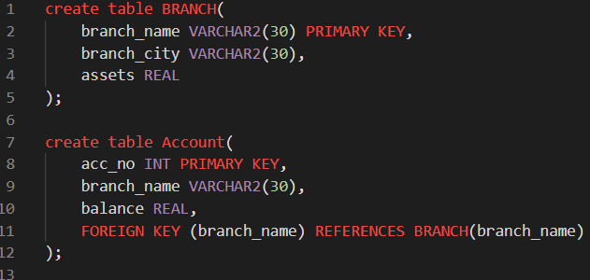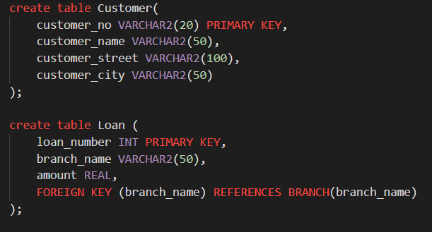
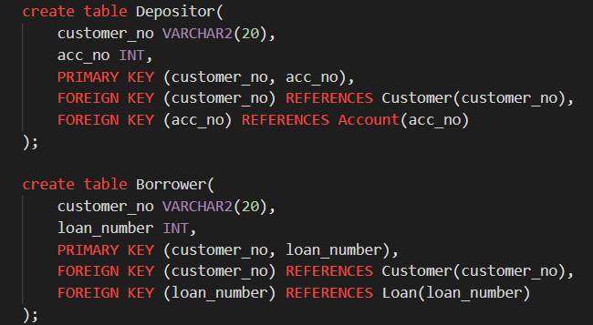
c)
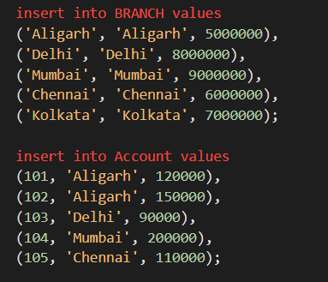
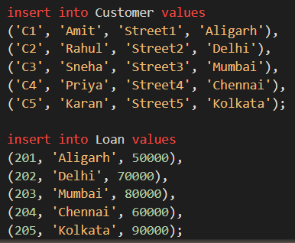
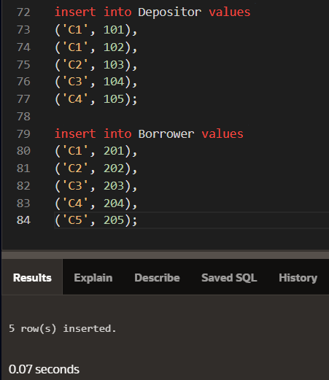
d)
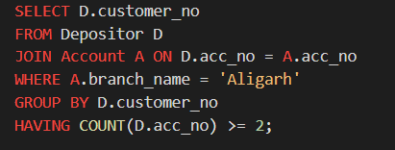
e)
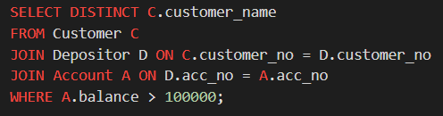
f)
